The Battle of the Neighborhoods (Week 1)

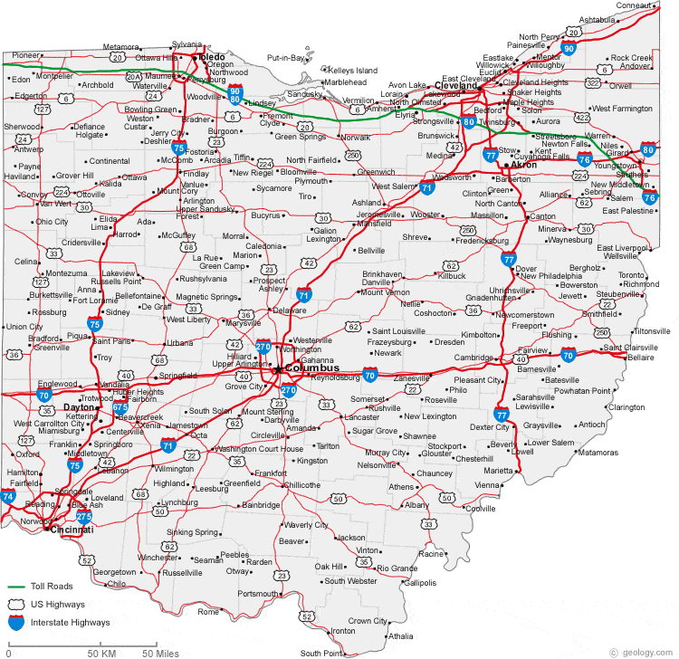

* 1. **Problem and Background**
     1. **Problem**
* Columbus may be the largest city in Ohio population-wise, but given its dearth of professional sports teams and overall irrelevance to the rest of the state, the main rivalry between in the state is between Cincinnati and Columbus. As a student at Ohio State, I hear this all the time: “Our city is better!” But rarely do I hear concrete facts cited as to why that is. Is one city more diverse than the other? Does one city have more to do than the other? Is there better food in one of the cities? The questions go on… and they continue to go on unanswered. Wouldn’t it be great if someone found a way to *objectively* state whether Cleveland or Cincinnati is better in a given area? I sure do.
  + 1. **Background**
* Separated by a 240-mile drive on Interstate-71, Cincinnati and Cleveland each own their respective corners of Ohio: Cincinnati in the Southwest and Cleveland in the Northeast. Including suburbs, the two cities account for around 40% of the state’s total population. Though outsiders typically regard the cities as being “total dumps” and “incredibly boring,” residents of the two cities are unanimously passionate about what their cities stand for. Cincinnatians love their chili on spaghetti, Oktoberfest celebration, cornhole, and beloved Bengals. Clevelanders, on the other hand, can’t get enough of Lake Erie, Cedar Point, Polish-boy sandwiches, and their beloved Tribe. Though it will be difficult to shoot any of those things down (minus the sports teams – go Bengals), comparing the things that both cities pride themselves on may lead to some interesting conclusions.
  + 1. **Interested Parties**
* The results of this analysis are for any Cincinnati or Cleveland native who constantly have to defend their hometown against people from the other city. From a business prospective, the results of this study could be used to convince people moving into Ohio to move to either one of the cities depending on what their priorities are.

**1.2. Data**

**1.2.1 Locations**

* I will be focusing on the urban/downtown areas of Cincinnati and Cleveland, so a simple google search should suffice for the location data. [1,2] These longitude and latitude values will be the center of a circular region where various venues are explored. The geopy package could also be used to find the longitude and latitude values of Cincinnati and Cleveland.

**1.2.2 Venues**

* To find numerous venues in downtown Cleveland and Cincinnati, I will be using the Foursquare API and previously mentioned location data.

**1.2.3 Sports Team Data**

* I thought this would be a fun one to explore. I’ll focus on the cities’ respective baseball and football teams since only Cleveland has an NBA team and only Cincinnati has an MLS team. Since neither city has won a championship in football or baseball in the past 30 years (Sorry 1990 Reds), I’ll focus on wins and losses, which can be found on numerous sports databases. [3,4,5,6]

**References:**

[1] https://www.latlong.net/place/cleveland-oh-usa-2643.html [2] https://www.latlong.net/place/cincinnati-oh-usa-6855.html [3] https://www.footballdb.com/teams/nfl/cincinnati-bengals/opponents [4] https://www.footballdb.com/teams/nfl/cleveland-browns/opponents [5] https://en.wikipedia.org/wiki/List_of_all-time_Major_League_Baseball_win%E2%80%93loss_records [6] http://mcubed.net/mlb/cle/cin.shtml